*from print to documents* **DP-G SERIES**

**Duplo®**

RELIABLE AND USER-FRIENDLY DOCUMENT PRODUCTION SYSTEM

### Double feed detection as standard

**130 prints per minute 300 x 600dpi resolution Stacking capacity of 1300 sheets**

**User ID manager Spot colour printing**

*Flyers, Exam papers, Leaflets, Promotional material, Certificates, Newsletters, Direct Mail, Instructions, Envelopes*

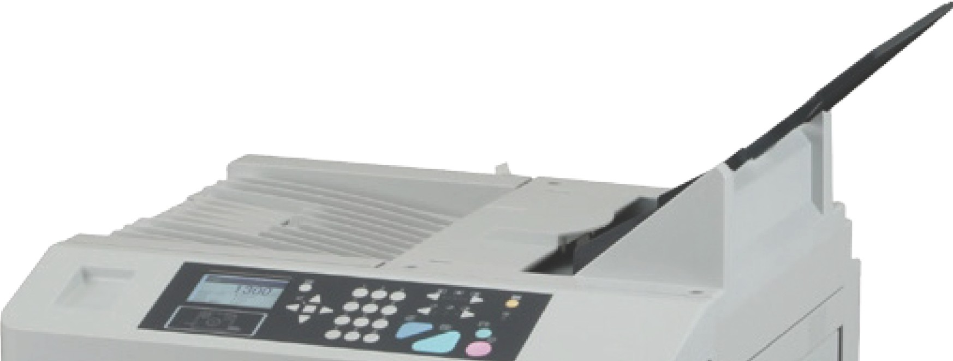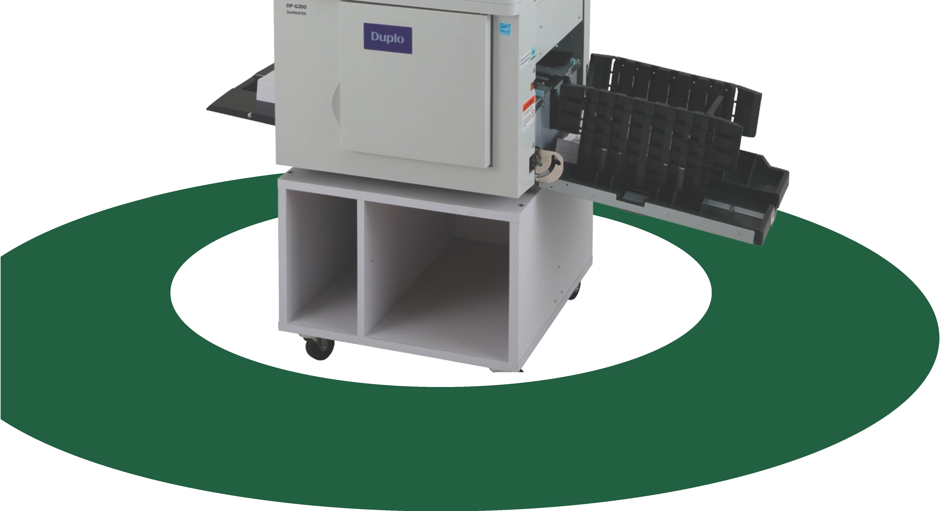



high def1mt1an

## imaging

### The DP-G series are Duplo's new mid-range Duprinters, replacing the best-selling DP-L series, The DP-G series has been designed to improve usability and performance with: a new larger LCD panel, a new stepper motor paper feed system, double feed detection

**as standard and neater stacking on paper output.**

The DP-G200 and DP-G300 are A4 document printing systems, whereas the DP-220 and DP­ G320 are B4 document printing systems.

The DP-G series duplicators are equipped with new ink that has a different nozzle shape. The new ink and masters are not compatible with previous models.

### High quality Printing

The DP-G series are equipped with a thermal digital master making process with a scan and print resolution of 300 x 600dpi, reproducing originals to exceptionally high standards.

The operator can scan via the flatbed scanner on the DP-G300 and DP-G320 or via the Automatic Document Feeder (ADF) on DP-G200 and DP­ G220. Alternatively you can print direct from a PC, Mac or via a network with theoptional USB

2.0 connectivity.

### Environmentally Friendly

The DP-G series conforms to a number of environmental standards. All the compatible inks on the DP-G series are water based inks.

The DP-G series feature an energy saving mode, which not only reduces the carbon footprint of a company, but also the running costs.

The re-usable resin master eject core further improves its environmental performance.

### High Productivity

The DP-G series can print up to 130 pages per minute. Master making interval time on the DP­ G300 & DP-G320 is 21 seconds and 23 seconds on the DP-G200 & DP-G220

Double feed detection now comes as standard to ensure accurate printing of sheets and a new stepper motor paper feed system further helps to improve productivity.

**Printing Process**

Scan the document via the ADF/ flatbed scanner Send document via computer/ USB



@t

**Exit tray**

**Paper** 0

**Delivery Tray Impression Roller**

**Straight Paper Path =Faster Print** & **Fewer Jams**

'''

•-

••• •

•,

|  |  |  |
| --- | --- | --- |
|  |  |  |
| [iii  [ l | • ... _..,.  ••• ***.....***  **T** |  |

DP-G Master 3.2 Inch LCD Control Panel Optional Tape Cluster

...

... .,.

••• ***r***

"•

•

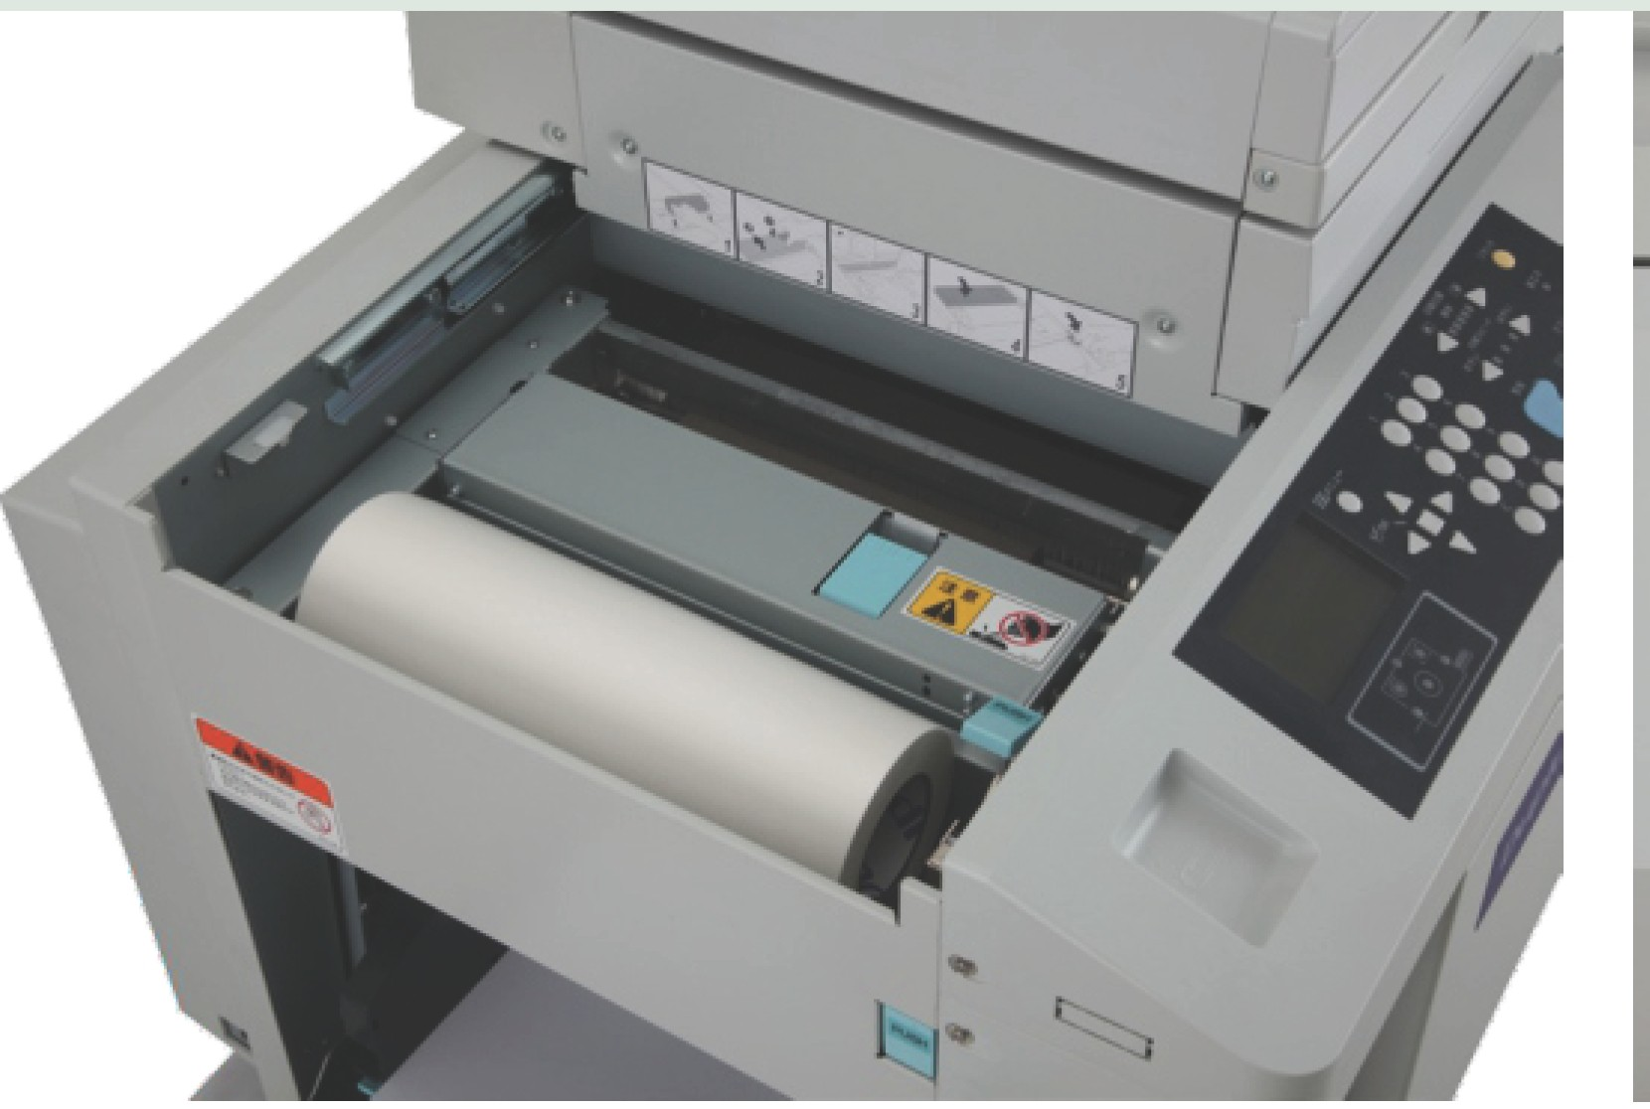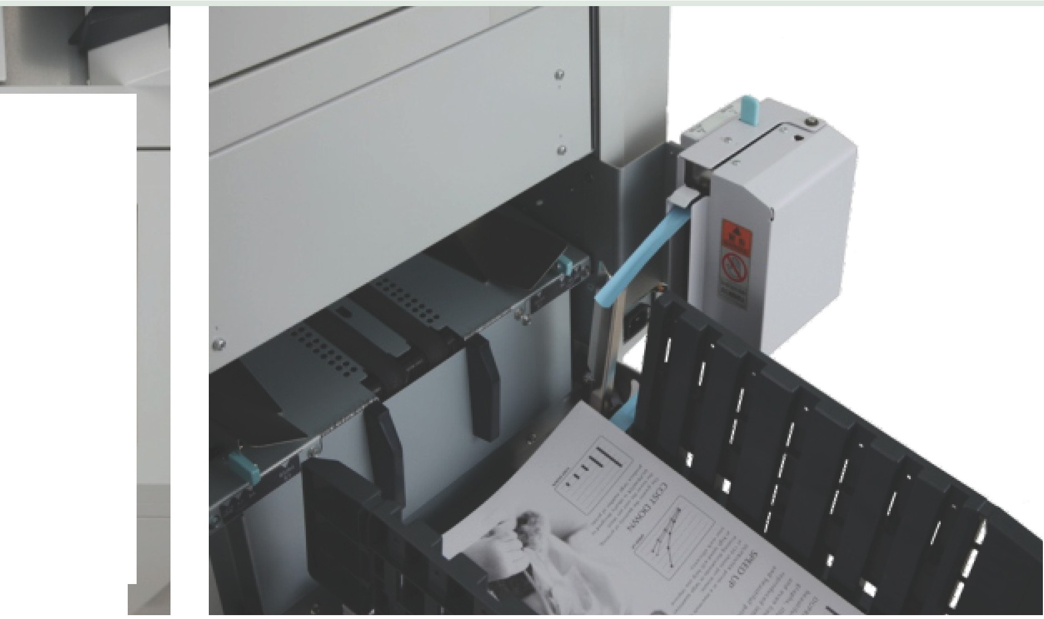

### Image Modes

As soon as an image has been selected, the Duprinters will automatically adjust its setting to ensure the print quality is at its best.

### User ID Manager

The user ID Manager is an excellent security feature and also a great way to control spending within a company.

Department User Password Prints

|  |  |  |
| --- | --- | --- |
| Accounts | 1000001 •••••• | 50 |
| Accounts | 1000002 •••••• | 100 |
| Accounts | 1000003 •••••• | 75 |
| Service | 1000004 •••••• | 60 |
| Service | 1000005 •••••• | 100 |
| Service | 1000006 •••••• | 50 |
| Service | 1000007 •••••• | 50 |
| Service | 1000008 •••••• | 80 |
| Marketing | 1000009 •••••• | 200 |
| Marketing | 1000010 •••••• | 80 |
| Marketing | 1000011 ****** | 50 |
| Marketing | 1000012 •••••• | 300 |
| Marketing | 1000013 •••••• | 1000 |

### Colour Printing

Create added value to your documents by adding a spot colour. A variety of coloured inks are available on the whole Duprinter range. A pantone colour service is also provided should a specific colour be required.

### Options: Tape Cluster

Tape cluster is an optional feature available

with the DP-G series. It enables the tape to be inserted between printing jobs even during high speed printing and speedily separate the printed paper into batches without interupting the printing process.

### 2 in 1 mode

When the DP-G series are equipped with ADF, the user can take advantage of the 2 in 1 feature which allows you to combine 2 documents in 1.

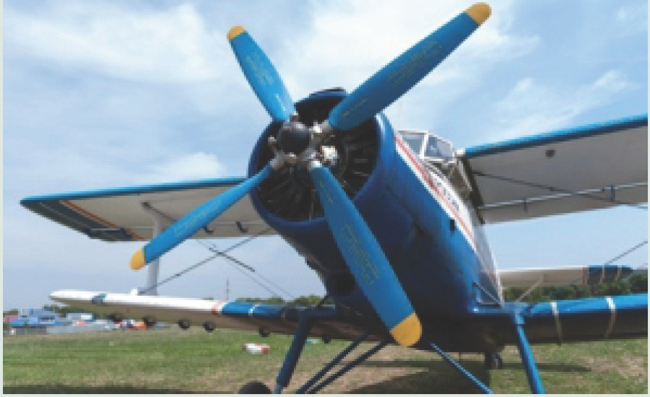**Reduction and enlargement** Document sizes can be enlarged and reduced. Reduction: 70%, 81%, 86%,

enlargement: 115%, 122%, 141%.

### Multiple Exposure

Increase productivity on the DP-G300 and DP-G320 by using the multiple exposure function. It is equipped with a 2-up, 4-up and 8-up function.

# ···+

···+

|  |  |
| --- | --- |
|  |  |
|  |  |

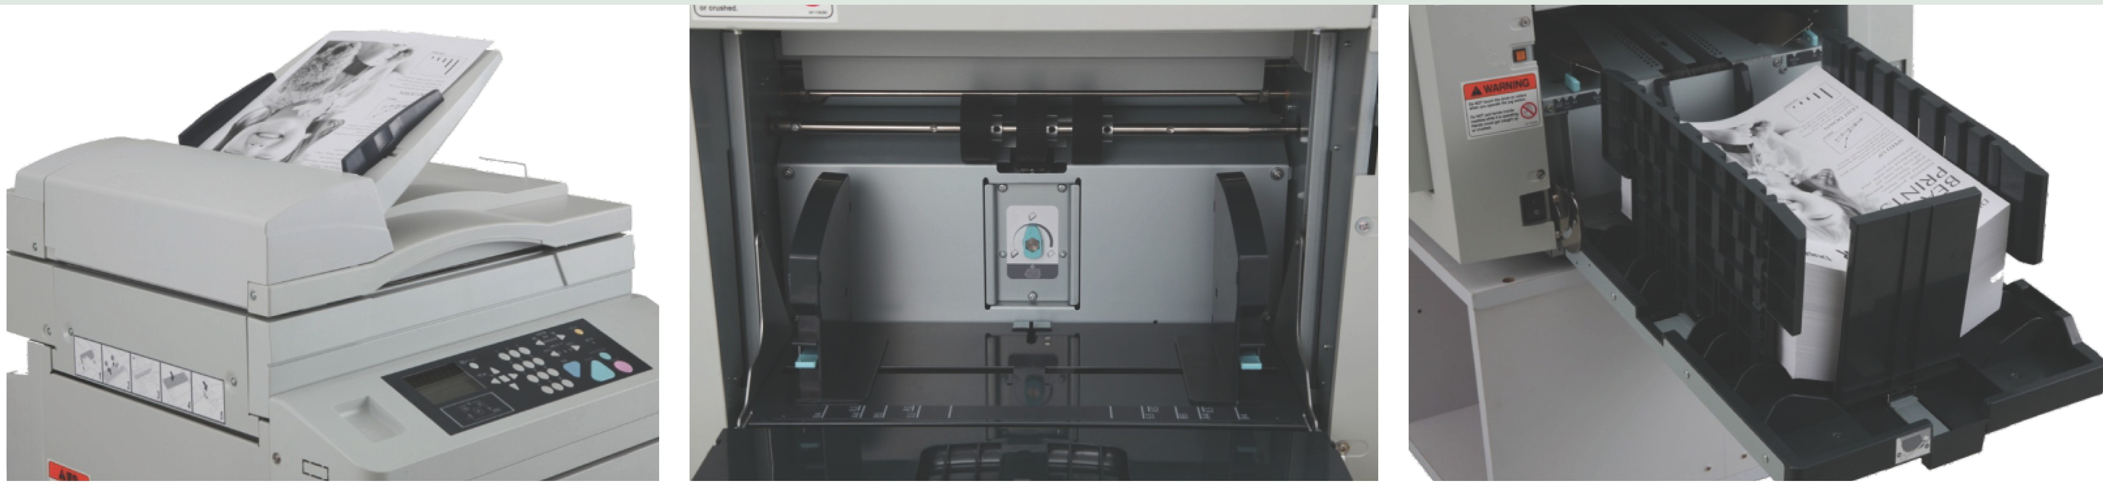

Automatic Document Feeder New Stepper Motor Paper Feed System B4 Stacker

**Technical Specifications**

### DP-G300 DP-G200 DP-G320 DP-G220

**Model Type**

**Master Making Method First Print Speed Resolution**

Table top digital duplicator Thermal digital master making

21 seconds 23 seconds 21 seconds 23 seconds

Scan: 300 x 600dpi, Print: 300 x 600dpi Master Punch density: 600 x 600 dpi

**Scanning Method** Flatbed scanner

**ADF Capacity** Optional, 100 sheets (64gsm)

Automatic document feeder

10 sheets (64gsm)

Flatbed scanner

Optional, 100 sheets (64gsm)

Automatic document feeder

10 sheets (64gsm)

**Printing Method Print Speed Max Print Area**

Stencil print

60-130 (A4) prints per minute

204x288mm 250x355mm

**Original Size**

Max: 297 x 432mm Min: 100x 148mm

Max: 271 x 382mm Min: 100 x 148mm

Max: 297 x 432mm Min: 100x 148mm

Max: 271 x 382mm Min: 100 x 148mm

**Print Paper Size**

**Paper Feeding Capacity Paper Stacking Capacity Paper Weight**

**Ink Volume**

Max: 297 x 364mm, Min: 100 x 148mm

**Max:** 297mm x 420mm, Min: 100 x 148mm 1300 sheets (64gsm)

1300 sheets (64gsm) 45-210gsm

600cc

**Power Supply Reduction/ Enlargement Zoom**

**Image**

100-240V 50/60Hz 1.6-0.8A

70,81,86, 115,122, 141%

50-200%

Text, Photo, Text/ Photo

**Multiple Printing Multiple Exposure Confidential Mode**

2 in 1 (optional)

2-up, 4-up and 8-up

2 in 1 printing Not possible

Yes

2 in 1 (optional)

2-up, 4-up and 8-up

2 in 1 printing Not possible

**Ink Supply Method Colour Print**

Automatic 600cc

Drum unit exchange

**Dimensions (W x D x** HJ

In use: 1270 x 615 x 666mm

When packed: 730 x 730 x 990mm

In use: 1270x 615 x 710mm

When packed: 730 x 730 x 875mm

In use: 1270 x615 x 666mm

When packed: 730 x 730 x 990mm

In use: 1270 x 615 x 710mm

When packed: 730 x 730 x 875mm

**Net Weight** 76kg (When packed: 90kg) 64kg (when packed: 76kg) 76kg (when packed: 90kg) 64kg (when packed: 76kg

**Duplo International Limited** Automated Precision House, Hamm Moor Lane, Addlestone,

Surrey KT15 250

Tel +44(0) 1932-263-900 - Fax +44(0) 1932-263-901

[info@duplointernational.com](mailto:info@duplointernational.com) - [www.duplointernational.com](http://www.duplointernational.com/)

Duplo is a trade mark of the Duplo Corporation. Duplo has a policy of continuous improvement and reserves the right to amend the above specifications without prior notice.

Production rates are based on optimal operating conditions and may vary depending upon stock and environmental conditions. As part of our continuous product improvement program, specificationsare subject to change without notice.

**CEO** Ref: 600DS/10/15